Insurance Fraud Detection Using Machine Learning
Data Collection & Preparation:
Activity 1: Collect the dataset
Description
The first step in any machine learning project is to obtain a relevant dataset. There are several popular open-source platforms for this purpose, such as Kaggle, the UCI Machine Learning Repository, and others.
For this project, we use a CSV file downloaded from Kaggle:
Link: Auto Insurance Claims Data
The dataset contains information about insurance policyholders, their vehicles, and reported claims. It includes a target column fraud_reported that indicates whether a claim was fraudulent (Y) or not (N). Understanding the structure and quality of this data is essential before any preprocessing or modeling can begin.

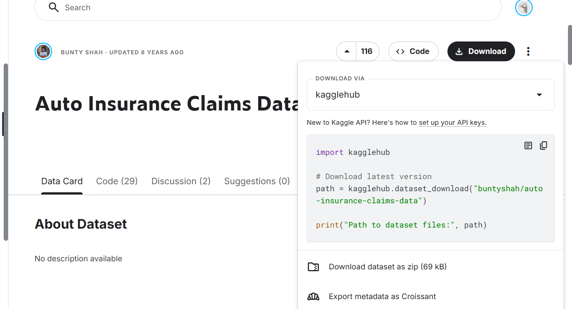

Activity 1.1: Importing the Libraries
Description
To work with the data effectively, we must import the necessary Python libraries. Each library provides specific functions that streamline data handling, visualization, and machine learning. The following libraries are used:
- NumPy (import numpy as np) – for numerical operations and array handling.
- Pandas (import pandas as pd) – for data manipulation and analysis; it allows us to read the CSV file and work with DataFrames.
- Matplotlib (import matplotlib.pyplot as plt) – for creating static, interactive, and animated visualizations.
- Seaborn (import seaborn as sns) – a statistical data visualization library built on Matplotlib, used for attractive and informative charts.
- Scikit-learn modules:
  - train_test_split – to split the dataset into training and testing subsets.
  - RandomForestClassifier, GradientBoostingClassifier, DecisionTreeClassifier, KNeighborsClassifier – various classification algorithms.
  - f1_score, classification_report, confusion_matrix – evaluation metrics.
- Utilities:
  - warnings – to suppress unnecessary warning messages.
  - pickle – for saving trained models.
  - scipy.stats – for statistical functions, including probability plots.
We also set the plotting style to 'fivethirtyeight' (as shown in the activity image) to enhance the readability of our charts, and we suppress warnings to keep the output clean.
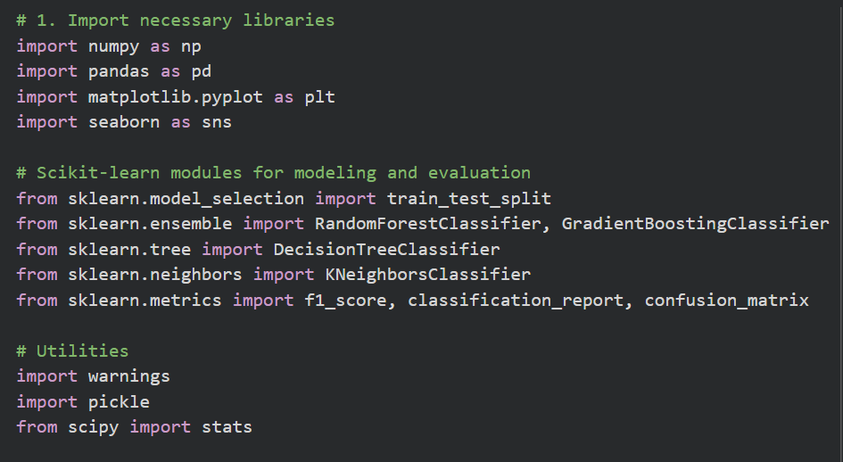

Activity 1.2: Read the Dataset
Description
The dataset is provided in CSV (Comma Separated Values) format. Using Pandas, we load the file with pd.read_csv(). In the Google Colab environment, we first upload the file manually using google.colab.files.upload(), then read it into a DataFrame named df.
python
df = pd.read_csv('insurance_claims.csv')
After loading, we perform an initial exploration:
- First five rows: df.head() shows the column names and a sample of the data. There are 40 columns, including policy details (e.g., policy_annual_premium), customer information (e.g., age, insured_sex), incident details (e.g., incident_type, incident_severity), and the target fraud_reported.
- Data shape: df.shape confirms that the dataset contains 1000 rows and 40 columns.
- Data types and non-null counts: df.info() provides a concise summary of each column’s data type and how many non-null values it contains.
- Missing values: We use df.isna().any() to identify columns with null values and df.isna().sum() to count them. The output reveals that two columns have missing data:
  - authorities_contacted – 91 missing entries
  - _c39 – 1000 missing entries (the entire column is empty)
Contrary to the statement in the activity description that no null values exist, our data inspection shows that missing values are present. Therefore, we cannot skip handling missing values; we must address them in the next step (Activity 2.1).
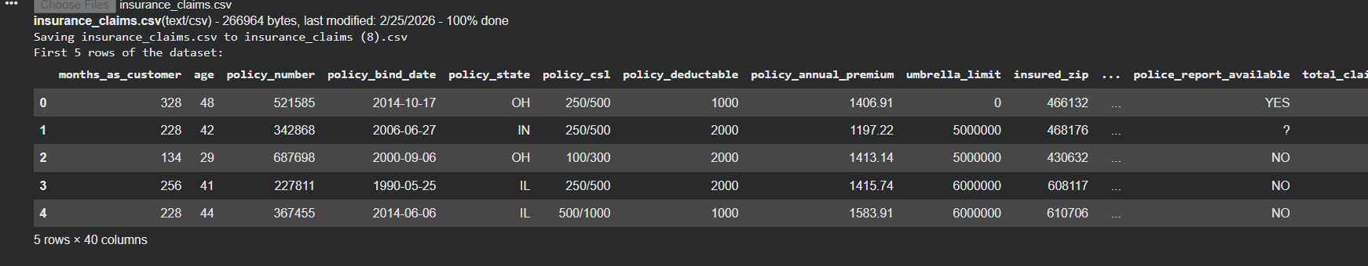

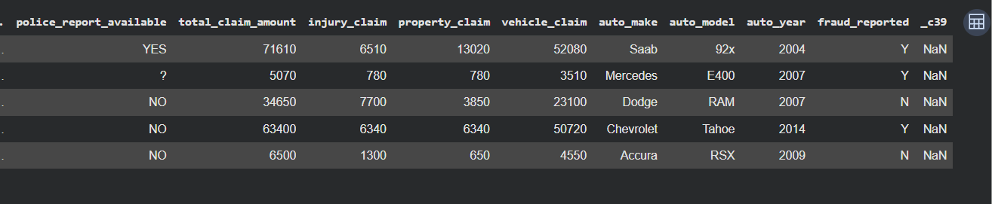

Activity 2.1: Handling Missing Values
Description
Missing data can degrade model performance if left untreated. We apply the following strategies:
- Dropping the useless column _c39 – This column is completely empty and provides no information. It is likely an artifact from the CSV file. We remove it permanently using:
python
df.drop(columns=['_c39'], inplace=True)
- Handling authorities_contacted – This categorical column has 91 missing entries (about 9.1% of the data). Rather than deleting these rows (which would reduce the dataset size), we impute the missing values with the placeholder 'None'. This preserves all records and treats the absence of a recorded authority as a separate category. The imputation is done with:
python
df['authorities_contacted'].fillna('None', inplace=True)
(An alternative could be to use the mode, but 'None' is more explicit.)
- Verification – After these steps, we run df.isna().sum().sum() and confirm that no null values remain. The dataset is now clean and ready for further preprocessing.

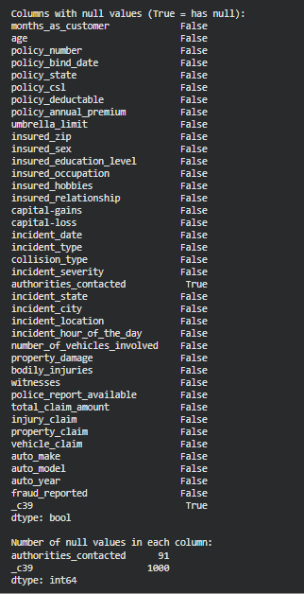
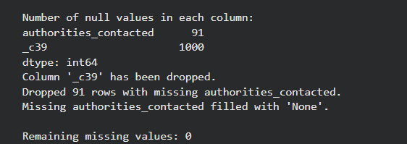

Activity 2.2: Handling Outliers
Description
Outliers are extreme values that can skew statistical summaries and adversely affect machine learning models. We focus on the policy_annual_premium feature, which represents the annual premium amount paid by the policyholder.
Visual Inspection with Boxplot
We first create a boxplot using Seaborn:
python
sns.boxplot(x=df['policy_annual_premium'])
The plot clearly shows several points beyond the upper whisker, indicating the presence of outliers.
IQR Method to Quantify Outliers
To objectively identify outliers, we calculate the Interquartile Range (IQR):
- First quartile (Q1) = 25th percentile
- Third quartile (Q3) = 75th percentile
- IQR = Q3 – Q1
The upper bound is defined as Q3 + 1.5 × IQR, and the lower bound as Q1 – 1.5 × IQR. Any data point falling outside these bounds is considered an outlier.
From the data we obtain:
- Q1 = 1080.13, Q3 = 1482.92, IQR = 402.79
- Lower bound = 475.94, Upper bound = 2087.11
This yields 77 outliers (approximately 8.5% of the data). These extreme values could bias our models if left untreated.
Log Transformation
Instead of removing outliers, we apply a log transformation to reduce their impact and make the distribution more symmetric. Because all premium values are positive, the natural logarithm is well-defined. We create a new column:
python
df['policy_annual_premium_log'] = np.log(df['policy_annual_premium'])
Visualizing the Effect
We define a function plot_distribution_and_qq() that displays a histogram and a Q-Q (quantile-quantile) plot side by side. The Q-Q plot compares the data distribution against a theoretical normal distribution; points following the diagonal line indicate approximate normality.
- Original feature: The histogram is right-skewed, and the Q-Q plot shows a clear deviation from the diagonal (especially in the tails), confirming non-normality and the presence of outliers.
- Log-transformed feature: The histogram becomes more bell-shaped, and the Q-Q plot points align much closer to the diagonal line, indicating a distribution closer to normal. The boxplot of the transformed values also shows a more compact range with fewer extreme points.
The log-transformed version of policy_annual_premium will be used in subsequent modeling steps to improve algorithm performance and reduce the influence of outliers.

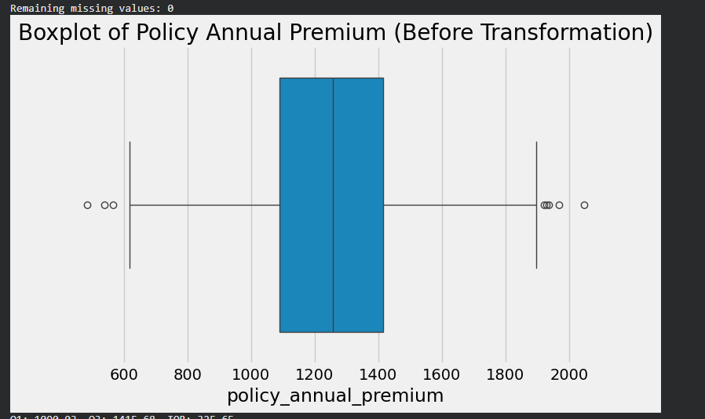

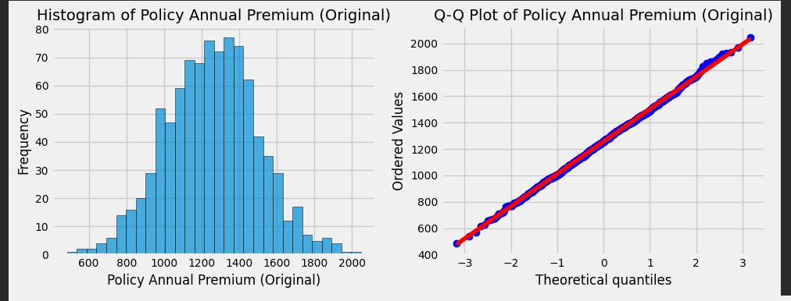

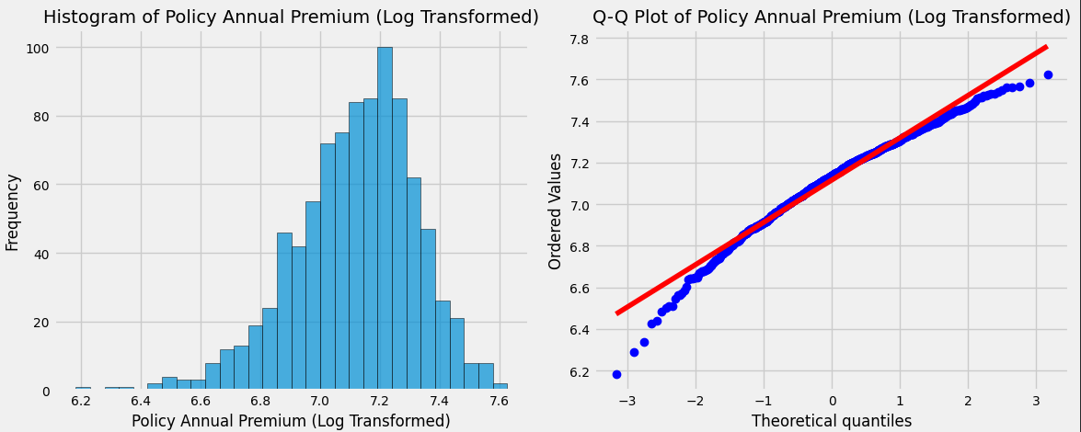
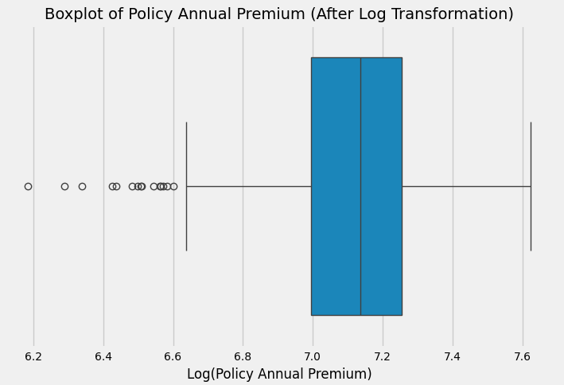

Code to perform above step:
# 1. Import necessary libraries
import numpy as np
import pandas as pd
import matplotlib.pyplot as plt
import seaborn as sns

# Scikit-learn modules for modeling and evaluation
from sklearn.model_selection import train_test_split
from sklearn.ensemble import RandomForestClassifier, GradientBoostingClassifier
from sklearn.tree import DecisionTreeClassifier
from sklearn.neighbors import KNeighborsClassifier
from sklearn.metrics import f1_score, classification_report, confusion_matrix

# Utilities
import warnings
import pickle
from scipy import stats

# Suppress warnings for cleaner output
warnings.filterwarnings('ignore')

# Set plot style (similar to fivethirtyeight.com)
plt.style.use('fivethirtyeight')

# 2. Load the dataset
# Upload file
from google.colab import files
uploaded = files.upload()

df = pd.read_csv('insurance_claims.csv')

# 3. Display first 5 rows to understand structure
print("First 5 rows of the dataset:")
df.head()

# Check which columns have any null values
null_check = df.isna().any()
print("\nColumns with null values (True = has null):")
print(null_check)

# Count total nulls per column
null_counts = df.isna().sum()
print("\nNumber of null values in each column:")
print(null_counts[null_counts > 0]) # show only columns with nulls

# Drop column '_c39' permanently
if '_c39' in df.columns:
df.drop(columns=['_c39'], inplace=True)
print("Column '_c39' has been dropped.")

# Remove rows where 'authorities_contacted' is null
initial_shape = df.shape
df.dropna(subset=['authorities_contacted'], inplace=True)
print(f"Dropped {initial_shape[0] - df.shape[0]} rows with missing authorities_contacted.")

# Fill with 'None' (or you can use the mode)
df['authorities_contacted'].fillna('None', inplace=True)
print("Missing authorities_contacted filled with 'None'.")

# Check total nulls again
print("\nRemaining missing values:", df.isna().sum().sum())
# Should be 0
# 1. Boxplot of policy_annual_premium (original) – already fine
plt.figure(figsize=(8,5))
sns.boxplot(x=df['policy_annual_premium'])
plt.title('Boxplot of Policy Annual Premium (Before Transformation)')
plt.show()

# 2. Compute quartiles, IQR, and outlier bounds
Q1 = df['policy_annual_premium'].quantile(0.25)
Q3 = df['policy_annual_premium'].quantile(0.75)
IQR = Q3 - Q1

lower_bound = Q1 - 1.5 * IQR
upper_bound = Q3 + 1.5 * IQR

print(f"Q1: {Q1:.2f}, Q3: {Q3:.2f}, IQR: {IQR:.2f}")
print(f"Lower bound: {lower_bound:.2f}, Upper bound: {upper_bound:.2f}")

outliers = df[(df['policy_annual_premium'] < lower_bound) |
(df['policy_annual_premium'] > upper_bound)]
print(f"Number of outliers: {len(outliers)}")
print(f"Percentage of outliers: {len(outliers)/len(df)*100:.2f}%")

# 3. Apply log transformation
df['policy_annual_premium_log'] = np.log(df['policy_annual_premium'])

# 4. Enhanced function to plot histogram + Q-Q plot with larger size and better readability
def plot_distribution_and_qq(data, feature_name):
fig, axes = plt.subplots(1, 2, figsize=(12, 5)) # Increased figure size

# Histogram
axes[0].hist(data, bins=30, edgecolor='black', alpha=0.7)
axes[0].set_title(f'Histogram of {feature_name}', fontsize=14)
axes[0].set_xlabel(feature_name, fontsize=12)
axes[0].set_ylabel('Frequency', fontsize=12)
axes[0].tick_params(axis='both', labelsize=10) # Adjust tick label size

# Q-Q plot
stats.probplot(data, dist="norm", plot=axes[1])
axes[1].set_title(f'Q-Q Plot of {feature_name}', fontsize=14)
axes[1].set_xlabel('Theoretical quantiles', fontsize=12)
axes[1].set_ylabel('Ordered Values', fontsize=12)
axes[1].tick_params(axis='both', labelsize=10)

plt.tight_layout()
plt.show()

# Plot original distribution
plot_distribution_and_qq(df['policy_annual_premium'], 'Policy Annual Premium (Original)')

# Plot transformed distribution
plot_distribution_and_qq(df['policy_annual_premium_log'], 'Policy Annual Premium (Log Transformed)')

# 5. Boxplot after transformation
plt.figure(figsize=(8,5))
sns.boxplot(x=df['policy_annual_premium_log'])
plt.title('Boxplot of Policy Annual Premium (After Log Transformation)', fontsize=14)
plt.xlabel('Log(Policy Annual Premium)', fontsize=12)
plt.tick_params(axis='both', labelsize=10)
plt.show()

